Snowflakes

When you live somewhere it doesn’t snow, you have to take matters into your own hands.

Click through for instructions on how to make these two-ingredient crystal snowflakes that will transform your house into a winter wonderland overnight.

What you’ll need:
–Borax laundry detergent booster
–water
–pipe cleaners
–string
–pencil, chopstick or popstick

Method
Step 1. Form your pipe cleaners into snowflake shapes. One long pipe cleaner can be cut into six pieces to make a simple star, or you can get fancier if you want. (Just remember that your snowflakes can’t be taller or wider than the container you’re going to pour your Borax solution into.)
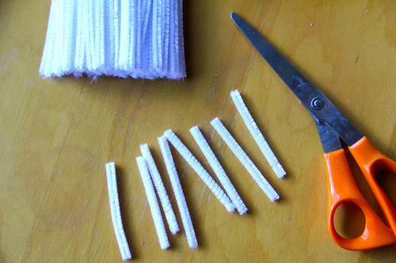
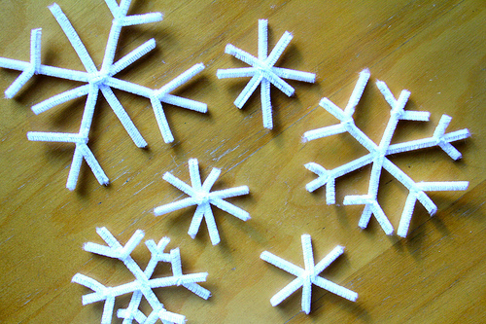
If you want to make long, straight icicles, that’s even easier. Just make sure you have a container tall enough that will hold the pipe cleaners without them touching the bottom.
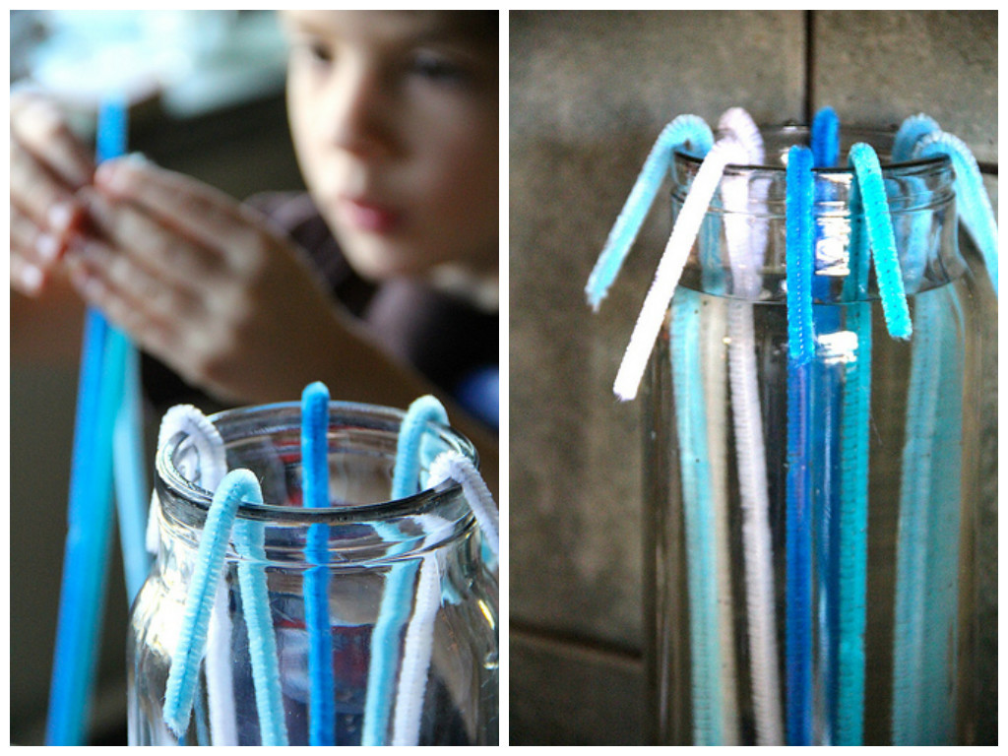
Step 2. Use string to tie your snowflakes onto a pencil or chopstick–anything long enough to span the container your using.

Step 3. Mix up a batch of Borax solution: 1/3 cup of Borax to 2 cups of boiling water. Stir the mixture until the Borax is dissolved, about 2 to 3 minutes.

Step 4. Submerge your pipe cleaner snowflakes in the Borax solution, making sure they don’t touch the sides or bottom of your container, or each other if you’re doing multiple snowflakes in one pot.
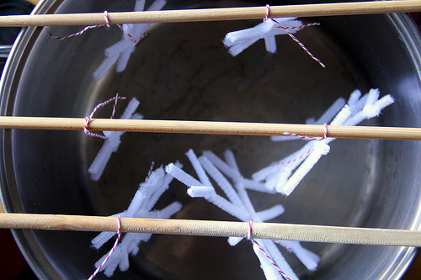
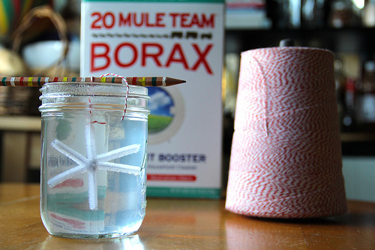

Step 5. Leave your Snowflakes overnight. Wake up the next morning check out your awesome crystal snowflakes!

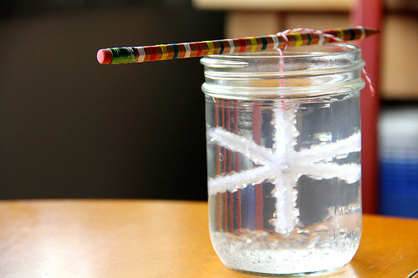
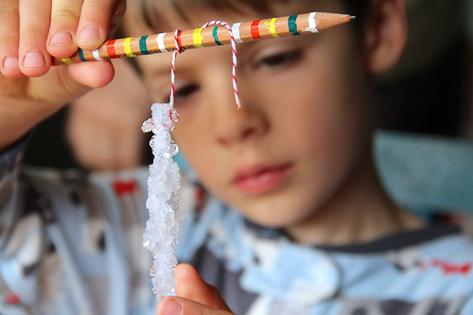
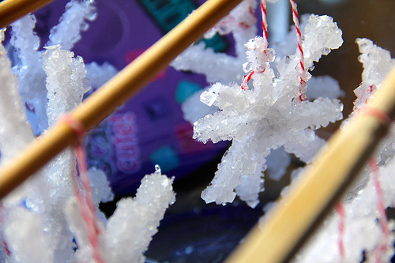
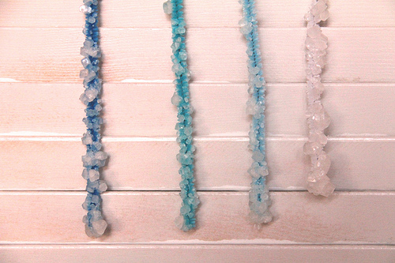
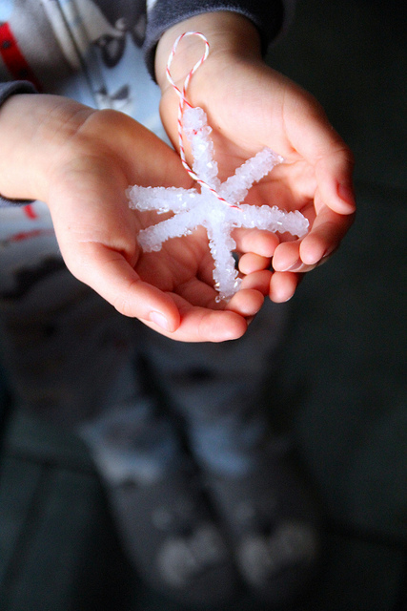
When you’re done, these look brilliant on a Christmas tree or hanging along a window, and they also add an extra little something to gift wrapping.
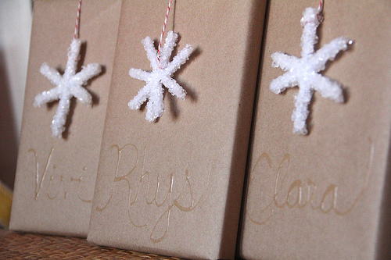
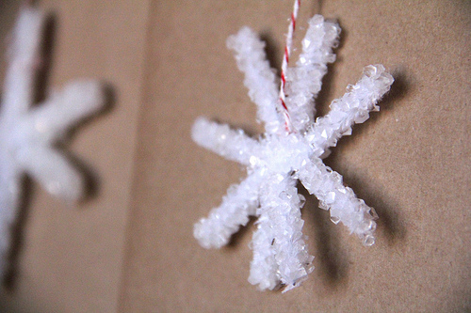

Can you a make different coloured Snowflakes?

